FRANCHISE AGREEMENT BETWEEN THE IOWA BIG PROGRAM AND NEW HAMPTON COMMUNITY SCHOOL DISTRICT
THIS FRANCHISE AGREEMENT is made and entered into on the 15th day of September, 2018, by and between the Iowa BIG Program (BIG) and New Hampton Community School District (Participant). The name “Iowa BIG” and the Iowa BIG logo, (Appendix A), are the exclusive property of Iowa BIG. Iowa BIG is a program co-owned by the Cedar Rapids, College, and Linn Mar Community School Districts.
This agreement is to provide the Participant membership into the “Iowa BIG North Consortia” (IBNC), going by the name “Iowa BIG North” for the purposes of providing BIG to students, educators and communities in the Charles City, New Hampton, North Butler, Osage, Riceville, Rudd Rockford Marble Rock and Turkey Valley Community Schools, Iowa. It is the responsibility of the Participants to develop and approve any necessary 28e or other agreements with other Participants in the IBNC for the effective and efficient operation of the IBNC. No District or entity can be a part of BIG at IBNC nor have any right to use the name “Iowa BIG” or “Iowa BIG North” without having an approved agreement with BIG.
The parties agree as follows:
- PURPOSE & RATIONALE: The purpose of this Agreement is to provide an opportunity for Participant to participate in BIG pursuant to the terms and conditions set out in this Agreement. Iowa BIG is a program designed expressly to provide learners with a learner-centered, transformational program that awards core academic credit and Iowa Common Core validation. It is also designed to show Iowa and the nation the possibilities for what high school can look like without the self-imposed constraints of school-centric thinking and assumptions. Iowa BIG has achieved national recognition for its innovative learner-centered model and desires to retain and advance its good standing in the transformational education space as well as expand the impact of this approach to more and more students in Iowa and the nation. BIG desires to support and include districts and consortiums of districts in implementing the program model and in helping accelerate this movement. While the program is designed to be contextually sensitive allowing Participant meaningful latitude in building BIG for their unique context, BIG also has a strong desire to ensure the integrity of the learner-centered model and that its core tenets are strictly adhered to. This will ensure that any program called Iowa BIG will be of the highest quality and reflect the foundational beliefs and behaviors BIG was founded on – protecting the interests of both BIG and Participant.

- TERM: The term of this Agreement shall be from the September 15, 2018 to June 30, 2019. The parties hereto agree this Agreement shall be effective upon its execution by all parties and the duration shall be coterminous with the provisions contained herein.

- RESPONSIBILITIES OF THE PARTIES:
BIG agrees to the following:
  - BIG has the exclusive right to the name Iowa BIG and grants Participant a limited license to use the name Iowa BIG pursuant to the terms and conditions of this Agreement.
  - BIG has the exclusive right to the Iowa BIG logo and will grant Participant the limited right to use the logo as part of the Participants participation in BIG and the ability to make minor modifications to the logo to include an identifier mutually acceptable to BIG and the Participant. BIG will have the exclusive right to any modifications to the BIG logo made by the Participant. Any use of or modification to the logo will be subject to the review and prior approval of BIG. The Participant’s ability to use the logo or any modifications to the logo shall be limited to the Participant’s participation in BIG pursuant to this Agreement.
  - BIG has an exclusive license to use the Project BBQ software and grants Participant a limited license to use the Project BBQ software pursuant to the terms and conditions of this Agreement. The Participant’s ability to use the Project BBQ software will be limited to the Participant’s participation in the Program pursuant to this Agreement.
    - The fee for Project BBQ is: $3,000 one-time setup fee; $1,000/per day onsite training; $2.00 per month per user, and; $1,000 annual school year refresh billed each August.
  - BIG will provide appropriate training to the Participant regarding the requirements of the program at the Participant’s expense. Specifically, this training is called, “Immersion Training.”
    - Immersion Training provides a comprehensive professional development experience for educators planning to teach in the BIG model. Immersion Training is a five-day program, running from 8:00 am Monday through 4:00 pm Friday at a date mutually agreeable at the founding Iowa BIG location at 415 12th Avenue SE, Cedar Rapids, Iowa. Participant’s trainees need to be available in the evenings as well as the training often includes evening events and gatherings.
    - Cost of Immersion Training is $2,000 per person or $5,000 for a three-person team. Additional trainees may be permitted upon mutual agreement and billed at $1,000 per person. Participant is responsible for expenses (travel, lodging, meals).
    - During the Immersion week, the Superintendent and/or designee will visit the Iowa BIG founding location to visit with BIG leadership and staff and receive an update and get any additional questions answered. This typically involves 2-4 hours either in the morning or afternoon.
    - Participants will experience a full-week cycle of the Iowa BIG model, have on-going and just-in-time opportunities to interact with staff and leadership to understand the model, and have time to begin planning and preparation for deploying BIG at Participant’s site.
    - BIG will provide a written and/or verbal report to the Participant’s Administration or designees at the conclusion of Immersion training by the Executive Director of Iowa BIG.
    - BIG will notify Participant administration or designees in the event it is clear that the educator(s) in the Immersion training lack the mindset and/or skill set to successfully implement the program. Educators not successfully completing the Immersion Training are not eligible to lead or be the sole educator at a Participant site nor can they speak or present on behalf of Iowa BIG outside Participant’s District. BIG highly recommends that Participant include BIG in initial screening/interviewing of potential candidates so BIG can help Participant better ensure the right fit and avoid unsuccessful Immersion experiences.
  - BIG will invite Participant to relevant professional development opportunities and charge a fee only if the Program would incur additional costs for the Participants involvement. Involvement in these opportunities is the decision of the Participant and such opportunities are considered part of the BIG’s ongoing support of the Participant.
  - BIG will make at least one annual site visit to the Participant’s location(s) to review the implementation of the program, provide support and guidance, and to ensure compliance with the program’s requirements and the terms and conditions of this Agreement at no cost to the Participant.
  - BIG will recognize Participant as a full member of the Iowa BIG family and include the staff, District, and sites on its Program webpage, www.iowabig.org.

The Participant agrees to the following:
  - The Participant’s implementation of BIG will be pursuant to the program’s requirements and the terms and conditions of this Agreement and are as follows:
  - The Participant will adhere to the requirements of BIG as set out by BIG as follows: The Participant:
    - Administrators, including the Superintendent and supervising principal/administrator will visit the originating program site prior to signing this agreement to ensure a careful understanding of the program.
    - Understands, believes in, and commits to putting into practice the tenets of learner-centered education as expressed in “A Transformational Vision for Education in the US” and “Practitioner’s Lexicon” (Appendix B).
    - Understands and adheres to BIG’s core design principles of Passion, Projects, and Community. Passion – student learning is driven by the learner’s interests and passions; Projects – learning happens and is validated through and within authentic, real-world projects and/or internships; Community – learning, and the projects and internships, happen in and with the community within which BIG operates and learning can be validated through experiences both in and outside the program.
    - Provides students the opportunity to earn core academic credit through BIG. BIG is not designed to be an opportunity outside or “after” the core academic program and standards. Electives may also be offered, but core academic credit will be a part of the Participants involvement in BIG.
    - Ensures that students are assessed and evaluated via identified competencies and standards and no false economies are used to assess and/or “control” students. (i.e. – no points, demerits, or prescriptive curriculum, etc.). Learning and validation of standards and competencies may be converted to traditional grades at the end of a semester or year for the purpose of transcripting the learning in ways understood by the District, state, and post-secondary institutions.
    - A BIG site, defined as having students in a physical location being led by an educator, must have an Immersion trained educator leading and working at that site. Additionally, any educator assigned to the program more than two hours per day must have successfully completed the BIG’s Immersion Training Program. Successful completion means meeting the following criteria:
      - Attends for the entire period of the Immersion Training (currently five days, from Monday at 8am to Friday at 4pm)
      - Is actively engaged and demonstrates strong learning and interest in the program and its core beliefs.
      - Is evaluated as satisfactory by the majority of the Immersion Training Team
      - Meets any additional criteria set forth by the Participant.
  - The Participant will pay BIG for required Immersion training. Participant will pay for ongoing PD mutually agreed upon by Program and Participant.
  - The Participant will use the Project BBQ software as part of the Program pursuant to the limited license provided by the Program to use the Project BBQ software for the duration of this Agreement. Project BBQ is licensed to the Participant. Participant, upon mutual agreement with BIG, may opt to not utilize Project BBQ until it reaches a 30 student threshold.
  - The Participant will allow BIG to conduct site visits with reasonable advance notice to review the Participant’s implementation of the program and the Participant’s compliance with the terms and conditions of this Agreement.
  - The Participant will provide all appropriate staffing, resources, and technology to implement the program pursuant to the requirements of BIG and the terms and conditions of this Agreement. “Appropriate” is defined as:
    - Staffing must maintain a minimum of 1 Immersion trained educator to every 30 students. When 130 students or more are enrolled, Participant must dedicate clerical/secretarial support to the team. Appropriate support can be determined by the Participant. Participant will need to designate and provide FTE time to a person or person(s) who develops projects and partnerships at such time that enrollment reaches 90 students. Program recommends this role as soon at Participant is able to provide such a role.
    - No single site may have more than 130 students enrolled. The Program strictly adheres to the research on effective community sizes to maintain positive relationships and, thus, holds the number at 130. After 130, another program site must be established and staffed.
    - Participant will provide funding from the District and may not run BIG strictly on grants or other funds that have a sunset. Participant must demonstrate a financial commitment strong enough to ensure sustainability beyond any start-up or growth grants/funding.
    - Participant will provide technology resources that are no less than what is provided to the regular academic program of the Participant.
  - The Participant may not include other Districts in this agreement or provide immersion training or support without prior consent from BIG. While consortiums of districts are encouraged, each individual entity or District must enter into this agreement with BIG.
  - Participant site(s) may become eligible to provide Immersion training, and be compensated for said training, to potential Participants and/or new staff either within their own Consortia or across the Program’s network provided Participant meets the following criteria:
    - Staff recommended as Immersion trainers for BIG must:
      - Successfully complete Immersion training;
      - Be full-time instructors in the Participants program;
      - Successfully complete a minimum of two-years as an Immersion Trained Program instructor;
      - Demonstrate a strong and on-going engagement, interaction, and learning with BIG and a commitment to advancing learner-centered education;
      - An instructor in good standing with both the Participant and BIG.
  - Participant may tuition-in students from area schools wishing to cooperate and be a part of the program but who do not have the numbers or resources to meet the requirements of being a full Participant with BIG. Tuition rates are fully determined by Participant. Participant must inform Program of any District’s involved in the Program in this way. District’s partnering with the Participant may be included and identified as an Iowa BIG district ONLY if they have a signed 28e agreement with BIG.
  - Participant may take part in conferences, workshops, and presentations to share their Iowa BIG story and act as spokesperson for the Participant’s program. Participant may not accept paid consulting and/or training opportunities without express written consent of BIG.
  - Participant will refer external inquiries about joining or starting an Iowa BIG program to the Program.

- INSURANCE AND INDEMNIFICATION

- To the extent permitted by law, BIG will indemnify and hold harmless the Participant from and against any and all losses, costs, damages and expenses, including reasonable attorney’s fees and expenses, occasioned by , or arising out of, the Program’s negligence or willful misconduct in the performance of its duties under this Agreement.
- The Participant will indemnify and hold harmless BIG from and against any and all losses, costs, damages and expenses, including reasonable attorney’s fees and expenses, occasioned by, or arising out of the Participant’s negligence or willful misconduct in the performance of its duties under this Agreement.

- ADMINISTRATION

- No separate legal or administrative entity shall be created by this Agreement. BIG’s Executive Director shall be designated as the administrator of the Agreement for purposes of Iowa Code Chapter 28E.
- No separate budget shall be established in connection with this Agreement.
- BIG and the Participant agree to cooperate in good faith in fulfilling the terms and conditions of this Agreement. Unforeseen difficulties or questions will be resolved by negotiation between BIG and the Participant.

- TERMINATION

- Termination for Cause. The occurrence of any one or more of the following events shall constitute cause for any of the parties included within this Agreement to declare another party in default of its obligations under the Agreement:
- Failure to make substantial and timely progress toward performance of the Agreement.
- Any other breach of the terms of this Agreement.
- Notice of Default. If a default occurs under Section 6A, the non-defaulting party shall provide written notice to the defaulting party requesting that the breach or noncompliance be immediately remedied. In the event that the breach or noncompliance continues to be evidenced ten (10) days beyond the date specified in the written notice, the non-defaulting party may either:
- Immediately terminate the Agreement without additional written notice; or,
- Enforce the terms and conditions of the Agreement and seek any available legal or equitable remedies.
In either event, the non-defaulting party or parties may seek damages as a result of the breach or failure to comply with the terms of the Agreement.
- Disposition of Property. Upon the expiration or earlier termination of this Agreement, each party shall have sole custody and use of its respective property.

- MISCELLANEOUS PROVISIONS:

A. The parties acknowledge and agree that if any paragraph, provision or term of this Agreement is deemed illegal or void by any court or other appropriate authority, the remaining provisions of this Agreement shall remain in full force and effect.
B. The terms of this Agreement may be amended at any time by mutual agreement of the parties.
C. This Agreement constitutes the full understanding of the parties, and no terms, conditions, understandings or agreement purporting to modify or vary the terms of this Agreement shall be binding unless hereafter made in writing and signed by both parties. Further, this Agreement constitutes a final written expression of all of these terms of this Agreement and is a complete and exclusive statement of those terms.
D. This Agreement is by and between BIG and the Participant only. There are no third-party beneficiaries to this Agreement.

- CONTACT PERSON: The Contact Persons shall serve until the expiration of the term of the Agreement or the designation of a substitute Contact Person. During the term of this Agreement, each Contact Person shall be available to meet as mutually agreed to review, discuss, and implement the terms and conditions of the Agreement. The Contact Persons are as follows:

Dr. Trace Pickering, Executive Director, Iowa BIG
Cedar Rapids Community School District
2500 Edgewood Rd. NW
Cedar Rapids, IA 52405

The Iowa BIG Program

By:__________________________________________ Date:_________________

By:__________________________________________ Date:_________________

Appendix A: Iowa BIG Logo

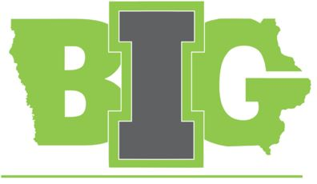

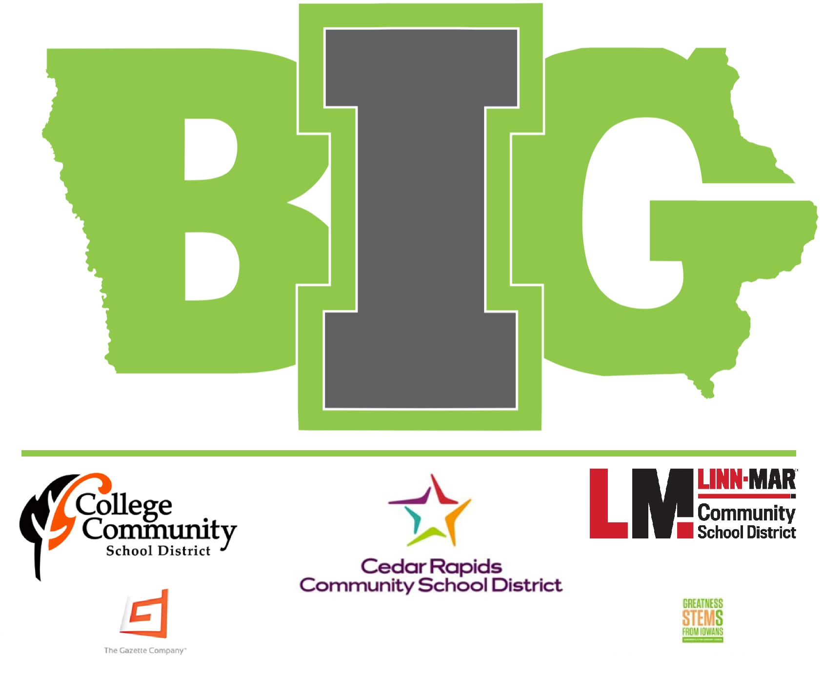

Appendix B:

A Transformational Vision for Education in the US

https://education-reimagined.org/wp-content/uploads/2017/01/A-Transformational-Vision-for-Education-in-the-US.pdf

A Practitioners Lexicon. What is meant by key terminology

https://education-reimagined.org/wp-content/uploads/2017/01/Education-Reimagined-A-Practicioners-Lexicon_download.pdf

