Mantronics Mailing Systems, Inc.
Proposal Prepared for New Hampton Schools
Proposal Prepared on Oct. 15, 2024
Model | Description | PROMO Purchase Price
IX7  Neoship  Meter  Rate insurance | Postage Machine  10 lb. scale and mixed mail feeder  Free USPS shipping software  Price locked for 3 years | $6,095.00  $65/month  Included
Maintenance | Price locked for 3 years | $640/year
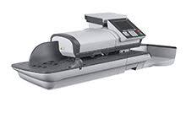
Includes shipping, installation and training.

The design of the system features an easy-to-use color touchscreen. Coupled with a mixed mail feed that process up to 140 lpm (iX-7) or 175 lpm (iX-7PRO), this system is designed for mid to high volume mailers. The iX-7 also meets the latest Intelligent Mail® Indicia (IMI) and Dimensional Weighing (DIM) USPS® requirements.;

