New Hampton Elementary Update
Linda Kennedy, Elementary Principal October, 2013
Character Counts! At New Hampton Elementary
October’s Pillar – Respect
New Hampton Community School District
Professional Learning Communities
PLC’s on Early Out Wednesdays: Preschool – exploring apps for student practice on iPads, Kindergarten – Facebook pages and Google Drive, First Grade – Evernote and Google Drive, Second Grade – Developing tables while revising the second grade report card, Third Grade – exploring apps for student practice on iPads and Google Drive, Fourth Grade – Google Drive
PLC’s for Lunch – Recently the Literacy Curriculum Committee met with two AEA consultants with questions for them regarding the Iowa Core to guide their work during their PLC’s for Lunch sessions.

Preschool Teachers are attending professional development sessions this year on the following dates in Calmar: September 11th, October 9th, November 13th, January 8th, February 12th, March 12th, April 9th, and May 7th

See attached October Newsletter

Visit the NHE Facebook page.

Homecoming Festivities

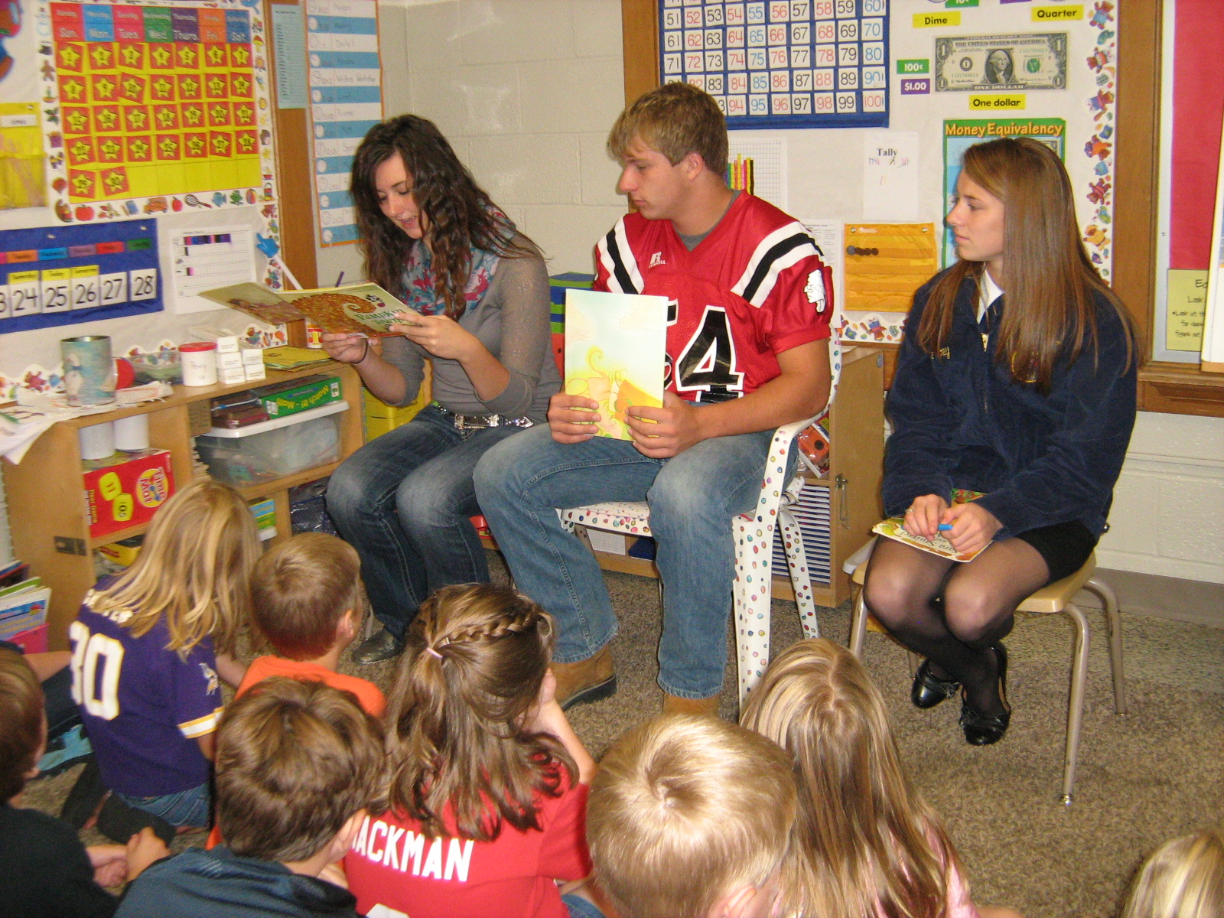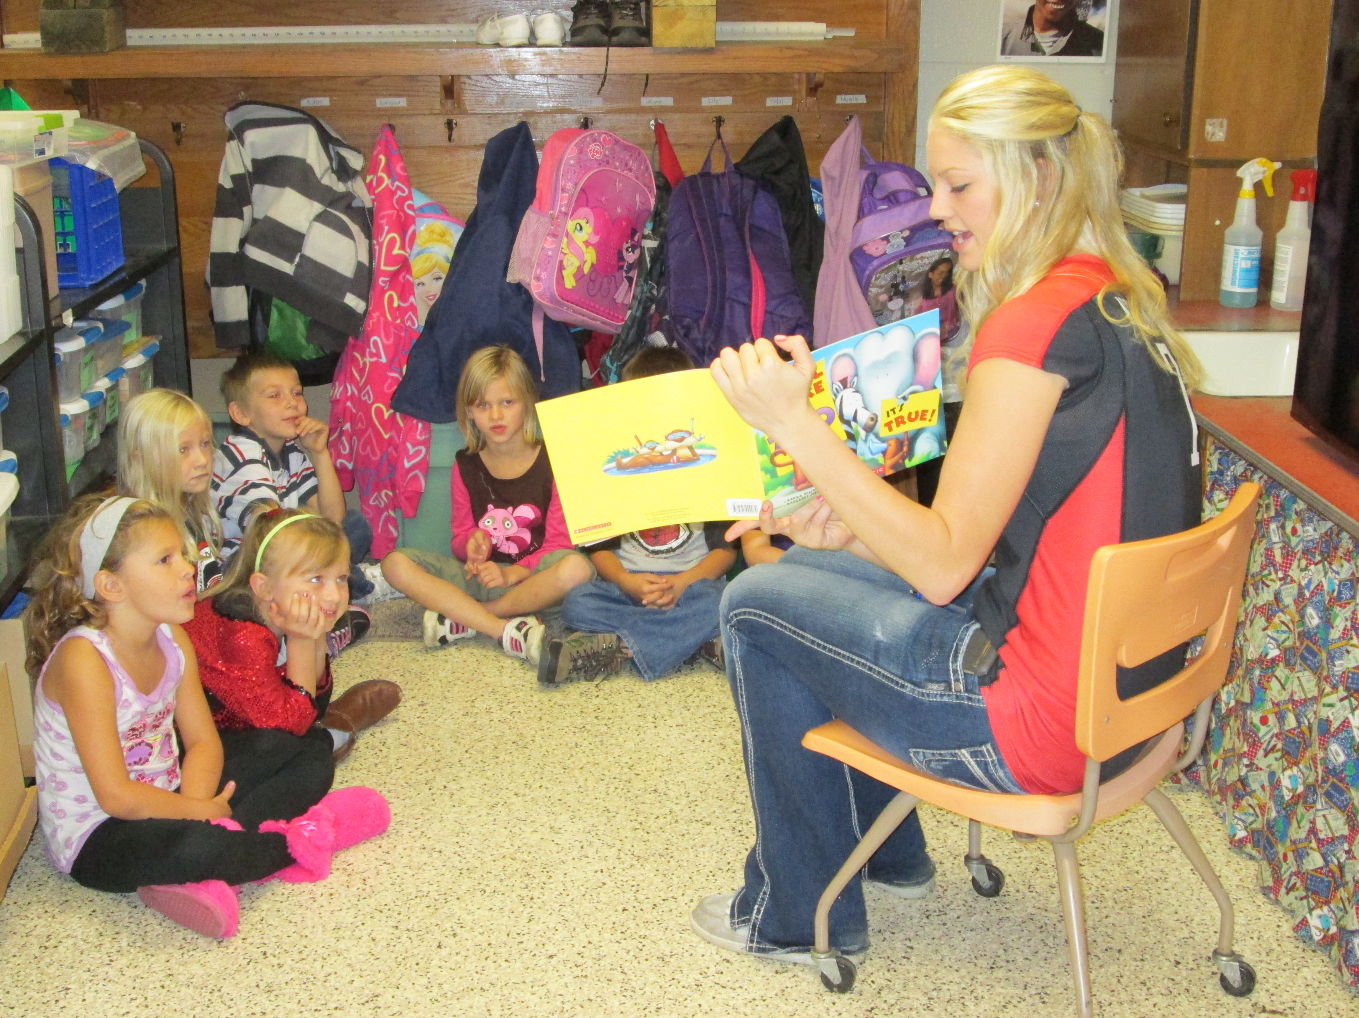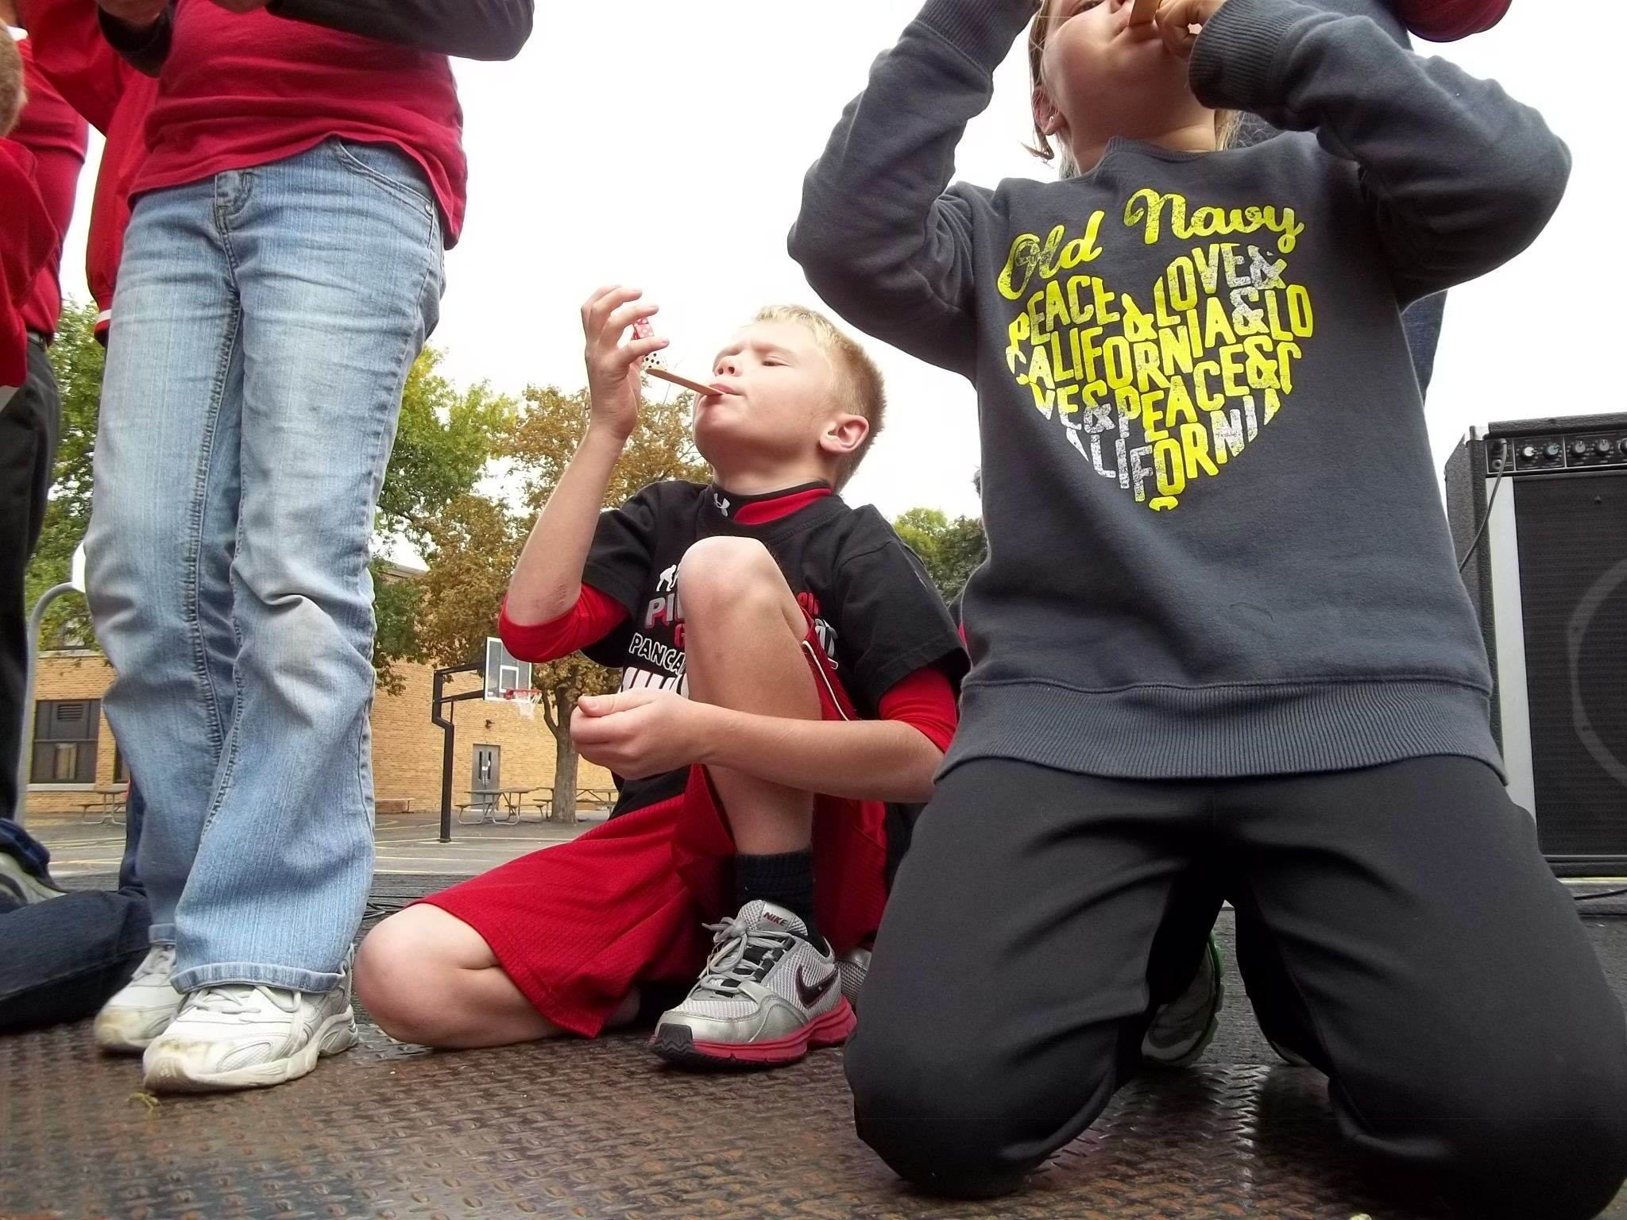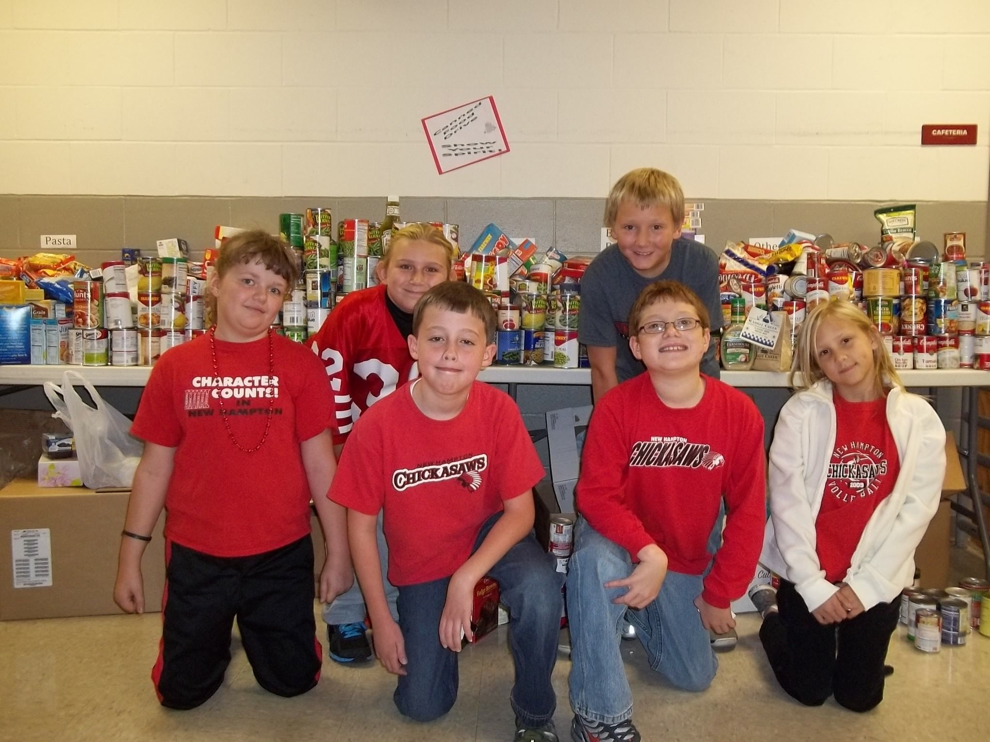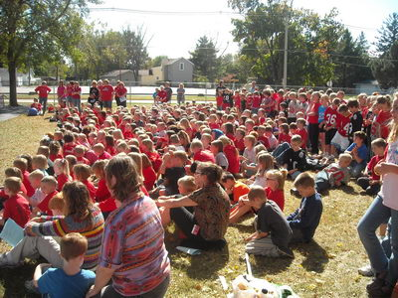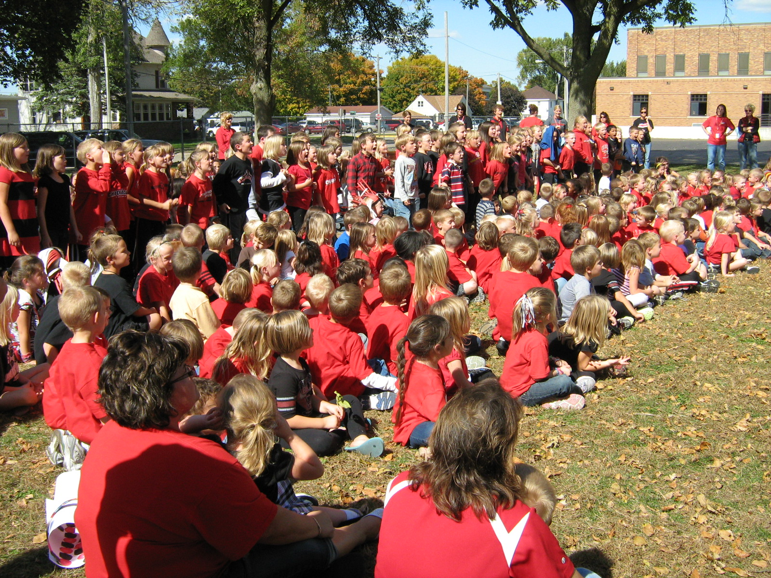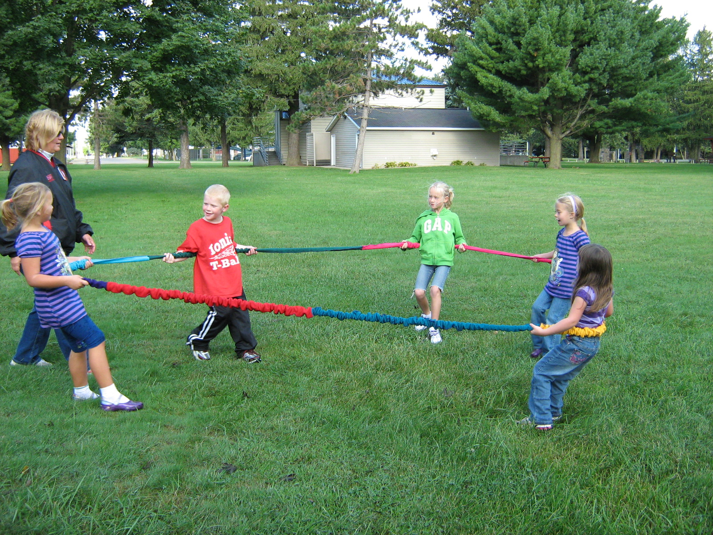
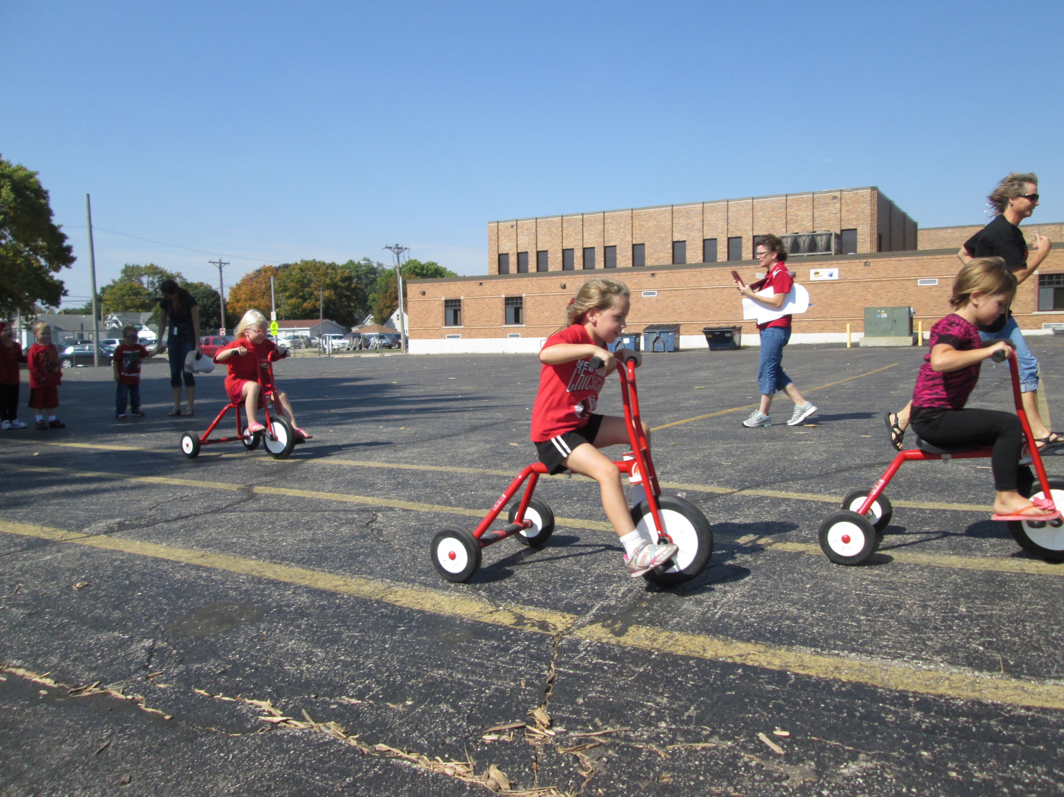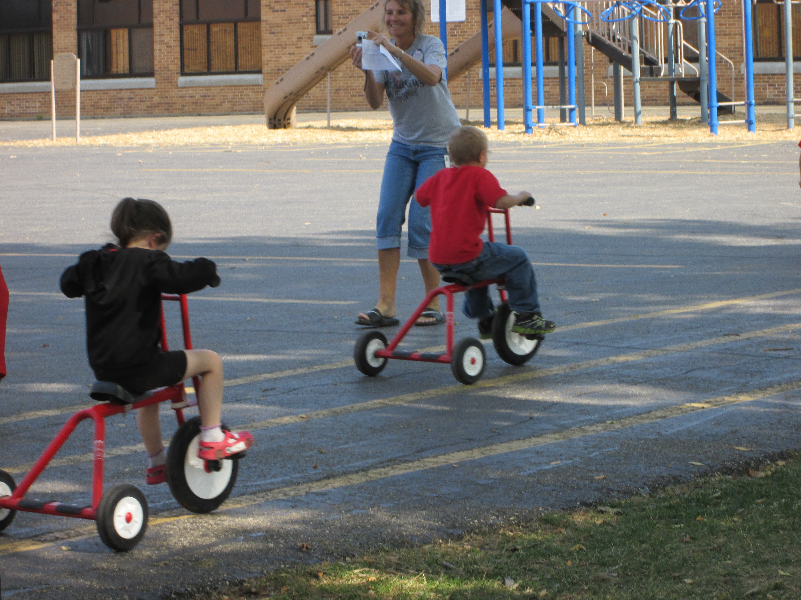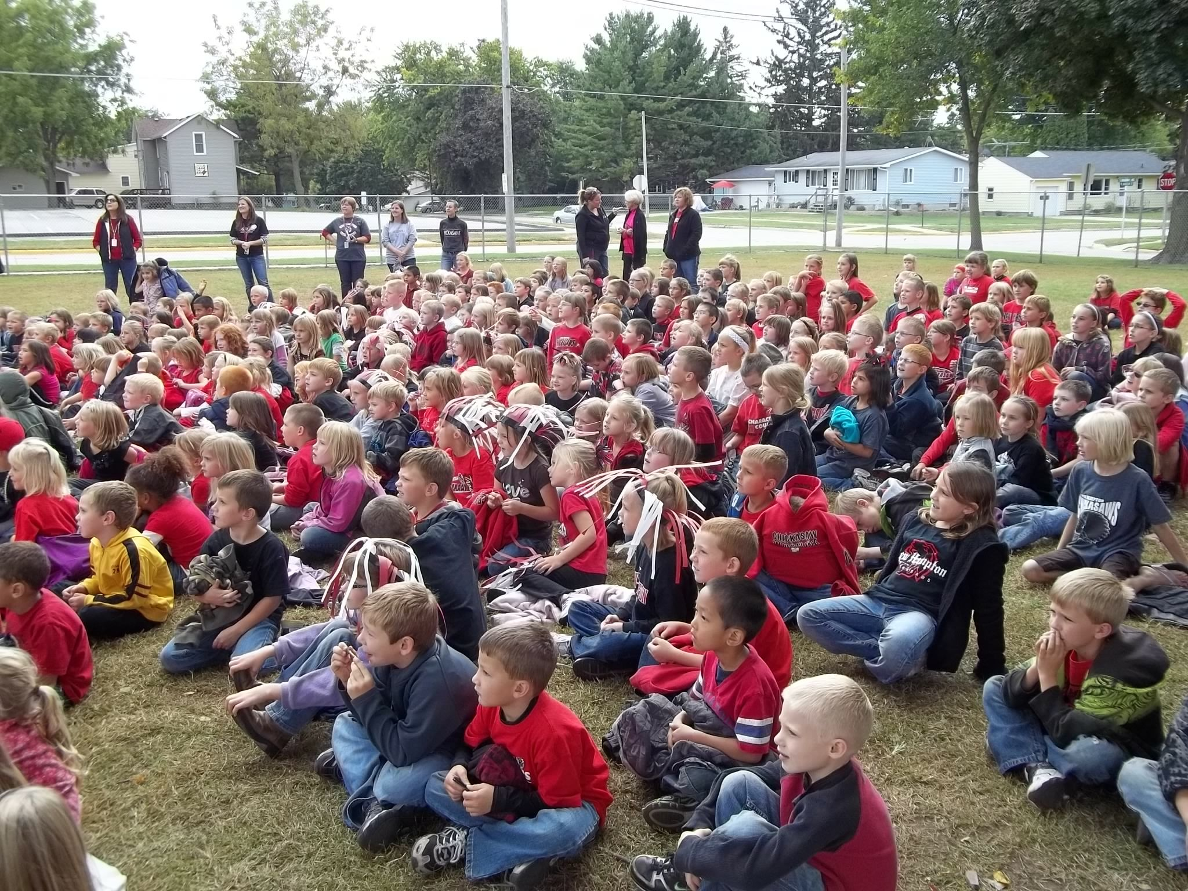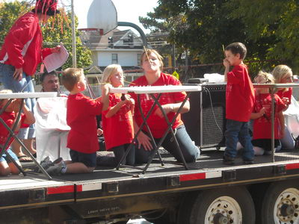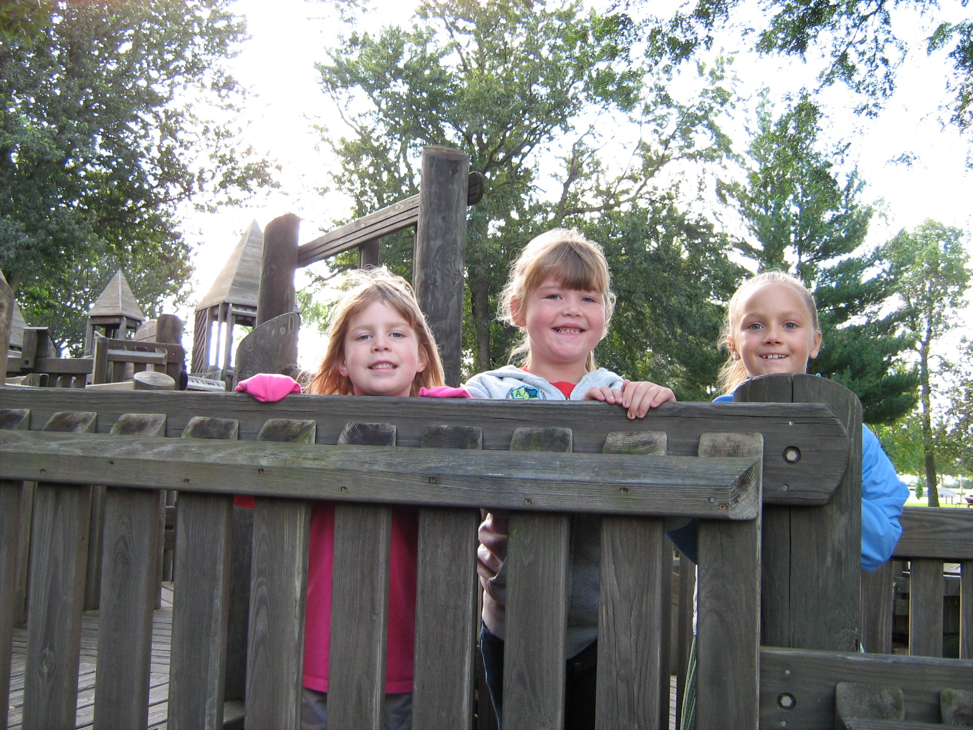

Celebrity Readers visited classrooms on Homecoming morning. Preschool students staged a trike race. Students enjoyed the weather and the program orchestrated by the Homecoming Committee. Each classroom staged a skit or displayed their skills for the rest of the students. Mrs. Mohling led the students in songs to display their school spirit.

NHE Homecoming Service Project
The biggest event of Homecoming week and the one that generated the most enthusiasm was the ‘Food for the Food Pantry’ contest. The spirit of caring, one of the six pillars, is alive and well at New Hampton Elementary. NHE students donated 1006 items to the food pantry!

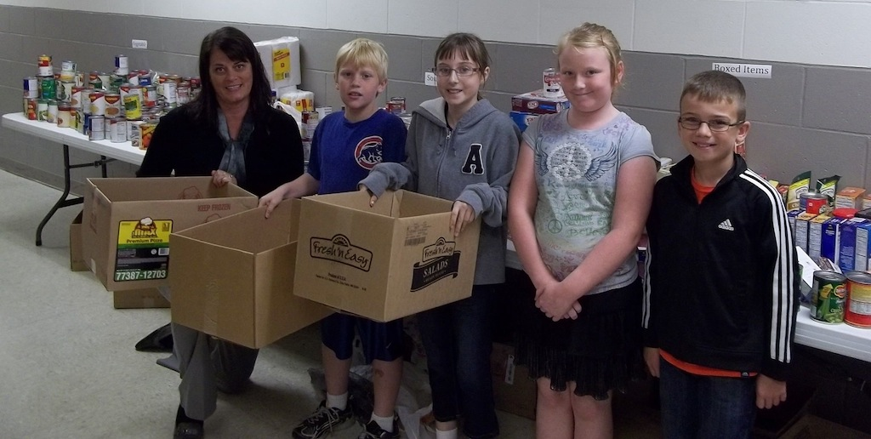
This picture shows some of the 1000 food items collected by New Hampton Elementary students. The students posing with the collection of food items are a few fourth graders from Mrs. Hoy’s room who are the Kids in Charge during this first quarter

Gant Piggy Bank Totals:

Accounts: 170

Total Deposits: $88,421.27

Iowa author, Joyce Crawford, visited NHE’s media center recently to talk with K – 4 students. She told them how she gets her ideas for books and shared her writing process with them.


